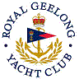 | Royal Geelong Yacht Club Inc.  Est 1859
Trophy Deed of Gift.

Trophy: | Apted Cup
Presented by: | Dr. John Apted
Date: | 1971
For: | Flying Fifteen Handicap Aggregate
Remarks / Revisions | 2006: Reallocated to Etchells Championship Aggregate
Click here for a list of Flying Fifteen Handicap Aggregate Recipients
Click here for a list of Etchells Recipients

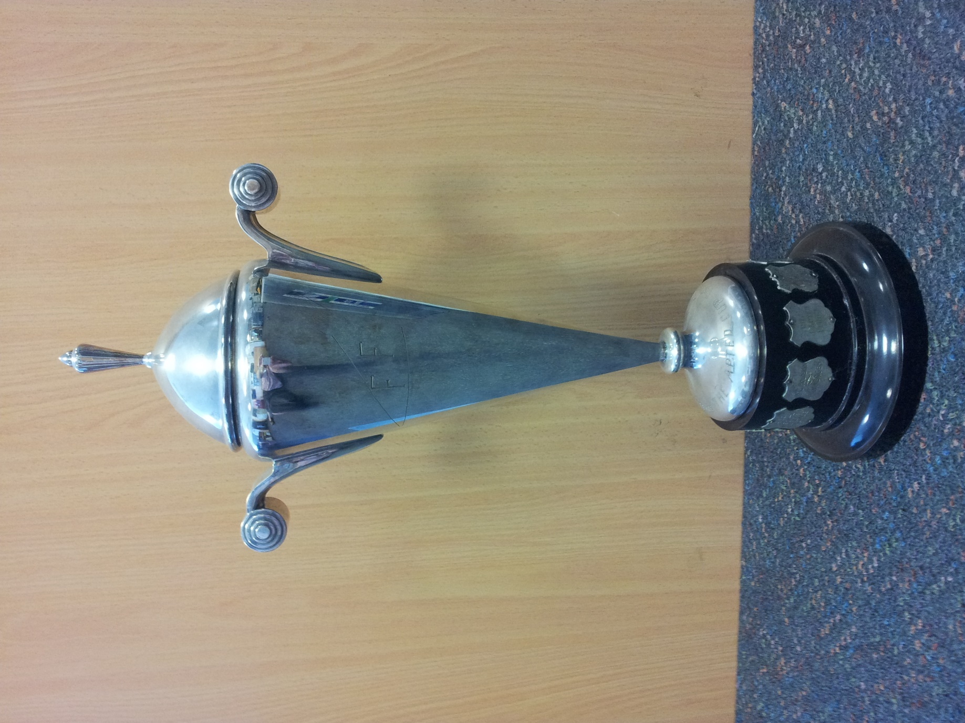

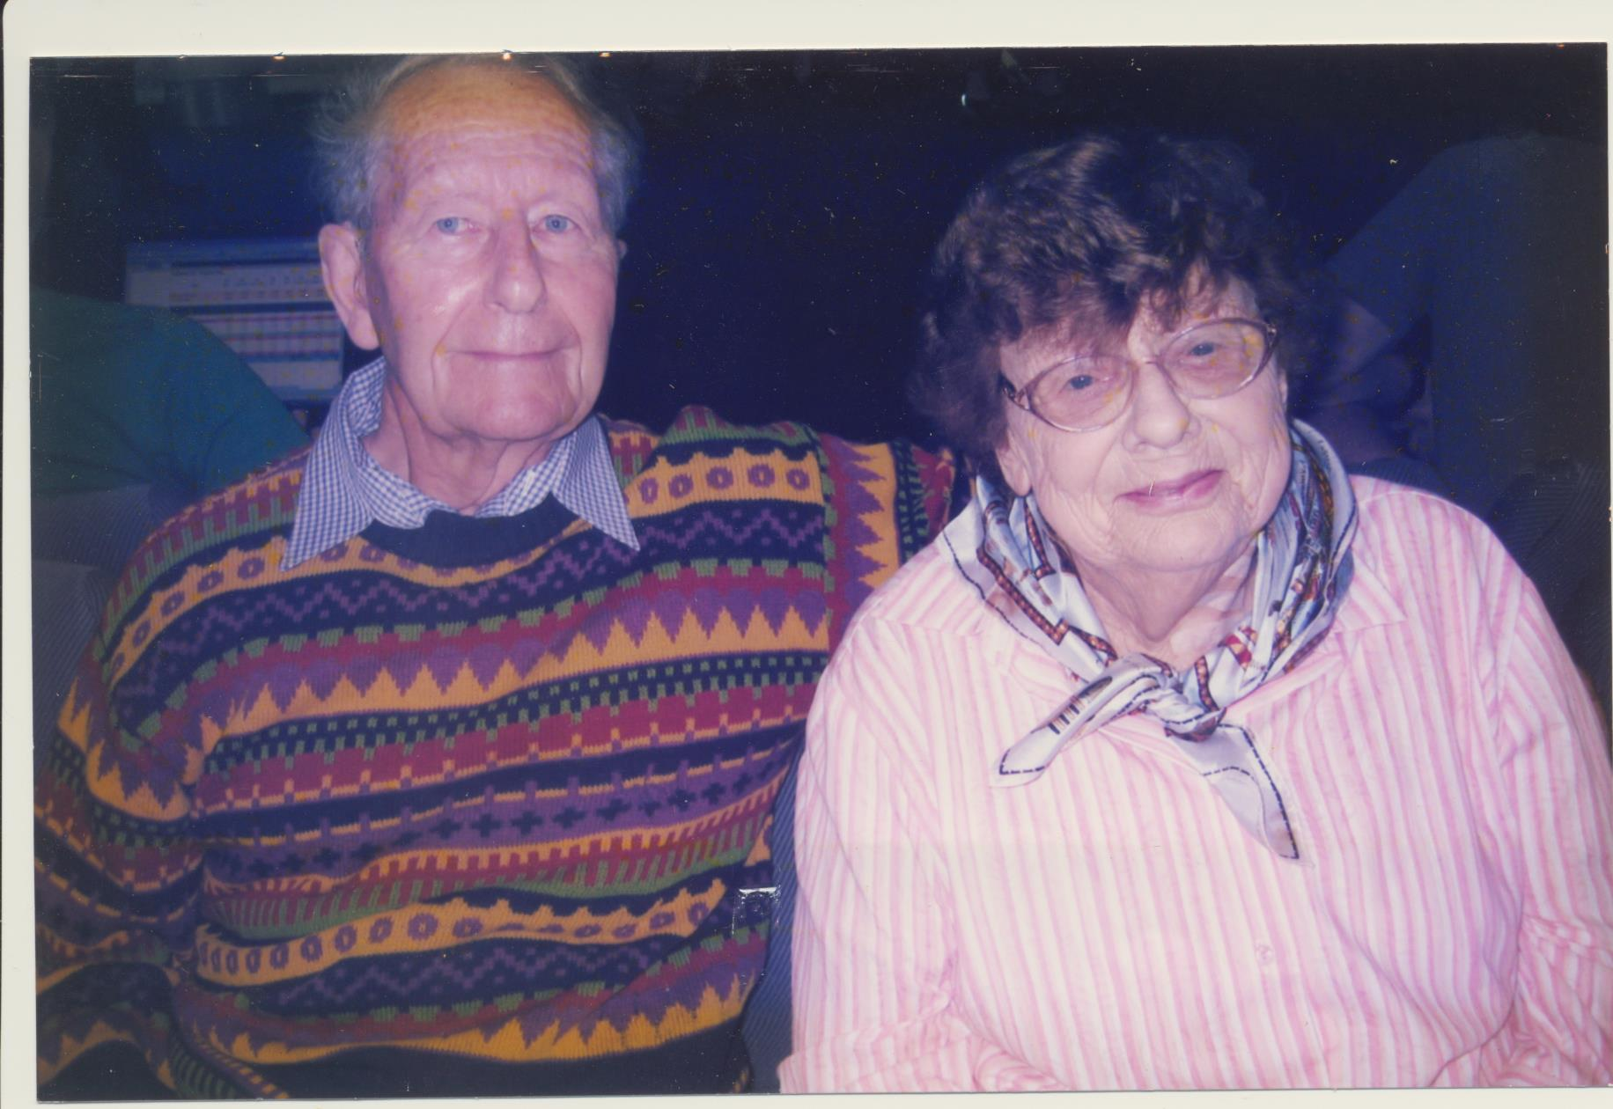
John Apted | Jonna Apted

The Apted Family moved to Geelong from St Mary's in Tasmania in 1956 and Dr John Apted joined Dr Godfrey Taylor in a General Practice in Donnely Avenue in Norlane . A few years later the practice had grown and moved to the corner of Spark's Rd and the Melbourne Rd in Norlane.
In 1961 we all moved to Sydney so Dr John Apted could study for his Dermatology Degree (DDM). We moved back to Geelong in 1964.
John and Jonna sailed together in Herons (Skidbladnir), Flying fifteens (Ffrigga), Diamonds (Finesse and Diana), Etchells (Boadicea), S80's (Rascal), Spider 32 (Spiderman), and an Endeavour 26 (Twinings).

